# Lab10

# quaternion Calc (Due in two weeks)

(To be completed in 2 weeks, before 8:00 10/3/16)

Create Zip file of the entire project directory named Lab10YourName.zip

Write a C# project that will carry out quaternion operations of a quaternion Calc. Create a new project and incorporate your old vector3 class. You should create a pleasant form layout. Use the x,y,z elements of q1 as the axis to rotate the point specified by Vector v about.

Design doc to cover angle between operation, both narrative and inner workings only. Design doc due next Tuesday in class.

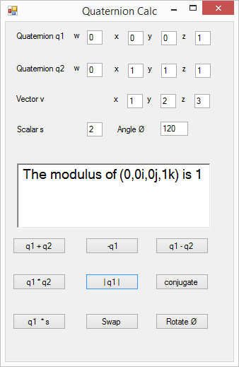

Marking scheme: Functionality 75%, Good comments 25%, variable name -25%, Bad comments -25%